Plastic Production

What is the environmental impact of just one single-use water bottle?

When we throw away a single-use drinks bottle, we are wasting more than just the plastic of the bottle. We are wasting the resources that created the bottle and the production of the bottle will leave a lasting impact on our climate because of the greenhouse gases that were released during its production.

These resources are used to make one single-use plastic bottle:

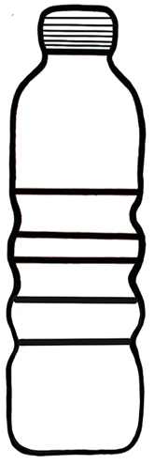

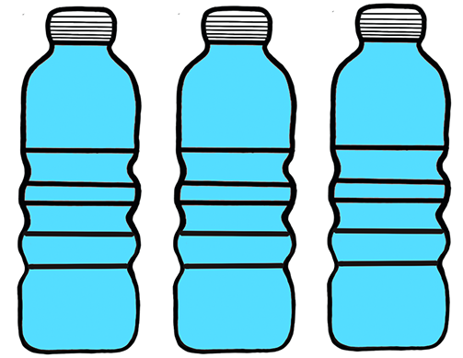
250 ml of oil, that is mined from beneath the ground, is used to make each bottle. That’s ONE QUARTER of the bottle’s capacity.

This oil is a fossil fuel and cannot be replaced once it is used.

THREE LITRES of water are used to make a ONE LITRE bottle!

What else could that water be used for?

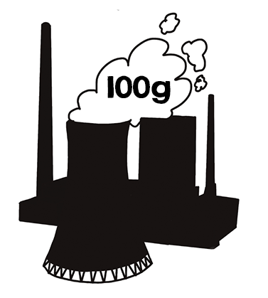
A 1-litre single-use plastic bottle weighs approximately 30g.
100g of carbon dioxide is released into the atmosphere for every 25g of PET (Polyethylene terephthalate), which is the plastic that makes many single-use drinks bottles.

In addition to the environmental impact of plastic production, single use plastic bottles have other effects on the environment:
Not all bottles are recycled. 70% of bottle go to landfill or is incinerated. Some (about 30%) are ‘downcycled’ to make fabrics, carpets or clothing, which often end up in landfill after one use and bottle tops are often not recycled and present a serious risk to wildlife when they enter waterways or the ocean.

