Where Does Plastic Go?

PMI

Teacher notes:
Use the images and information (or just images to inspire questions, initially) to encourage children to discuss the Plus, Minus and Interesting points about the different methods of plastic disposal. It is important to note that the three main disposal methods will require transportation and this will cause the emission of greenhouse gases from transport and, unless it is certain that electricity from a sustainable source is used, it is likely that fossil fuels were used to create the electricity required to process plastic, therefore causing additional emission of greenhouse gases.

You could guide pupils to consider the management of plastic waste in different ways:

- Which method produces the most/ least greenhouse gases?
- Which method poses most risk to the environment?
- Which method poses most risk to wildlife?
- How could we improve one or more of the disposal methods?
- If you could only use one of the plastic disposal methods, which would you recommend and why?

Landfill
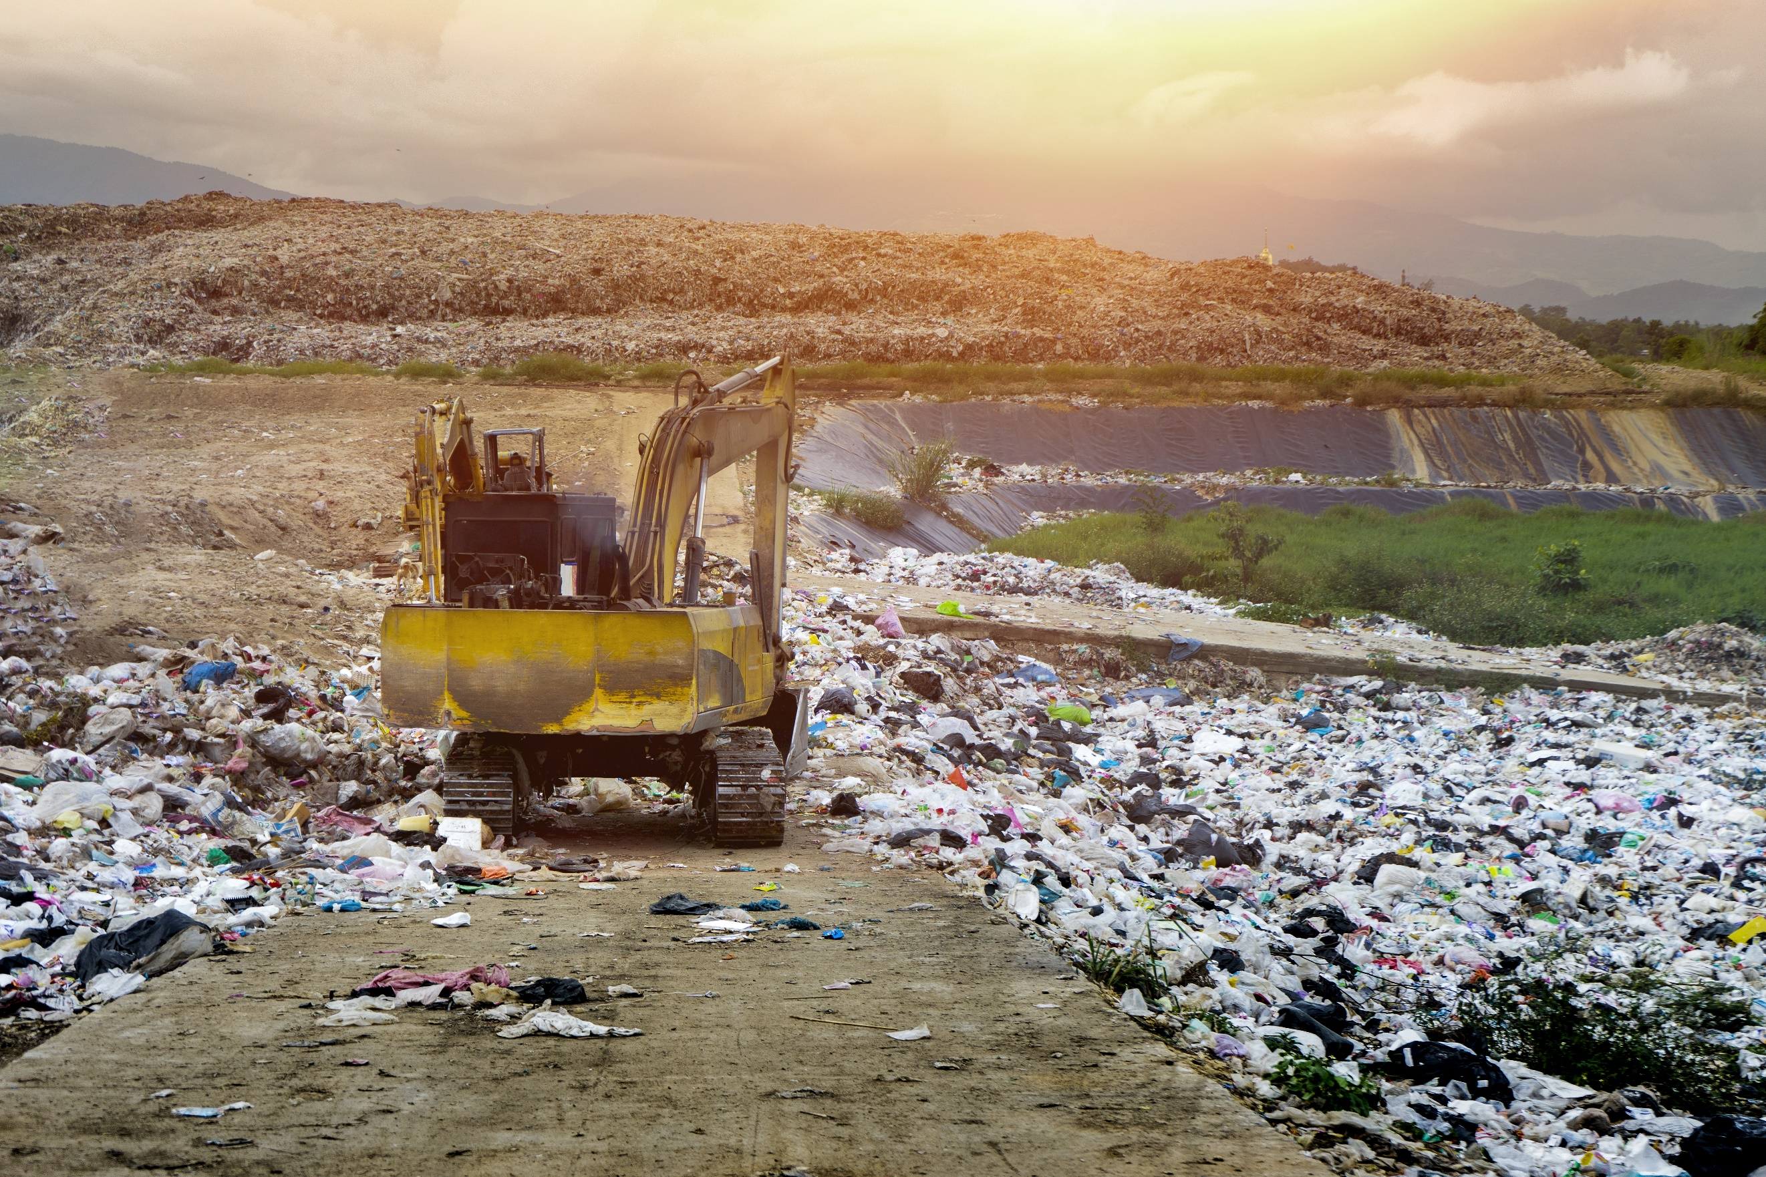
Plastic and other waste is transported to and buried in large holes in the ground. In most cases, large holes are filled with a liner and waste is buried and repeatedly covered with soil. Plastic does not biodegrade (break down) and so plastic will stay buried underground for a very long time (up to 1000 years). It is thought that chemicals from plastics can be washed into the surrounding soil and into underground water supplies.

Plus | Minus | Interesting

Incineration
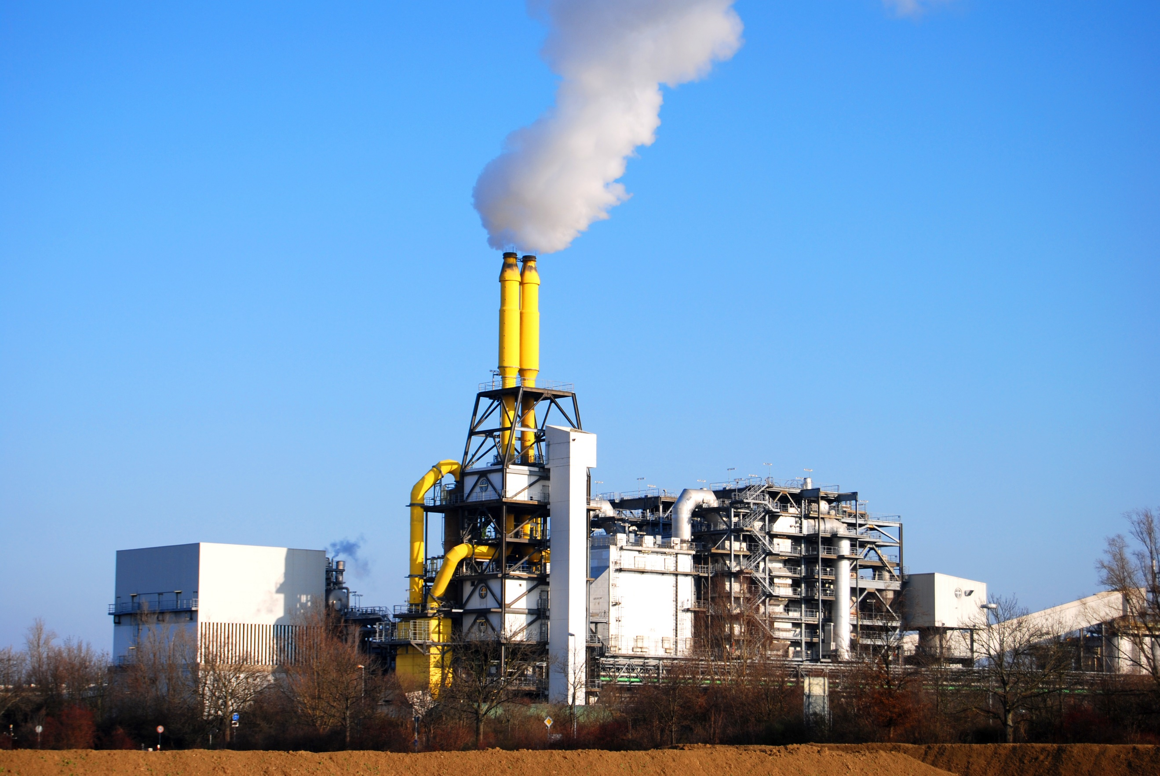
Plastic waste is collected, transported and burned to dispose of it. Sometimes, the heat from burning the plastic waste is used to create energy and electricity but the burning process creates a lot of pollution, including greenhouse gases. Carbon dioxide and chemicals are released into the atmosphere when plastic waste in burned.

Plus | Minus | Interesting

Recycling
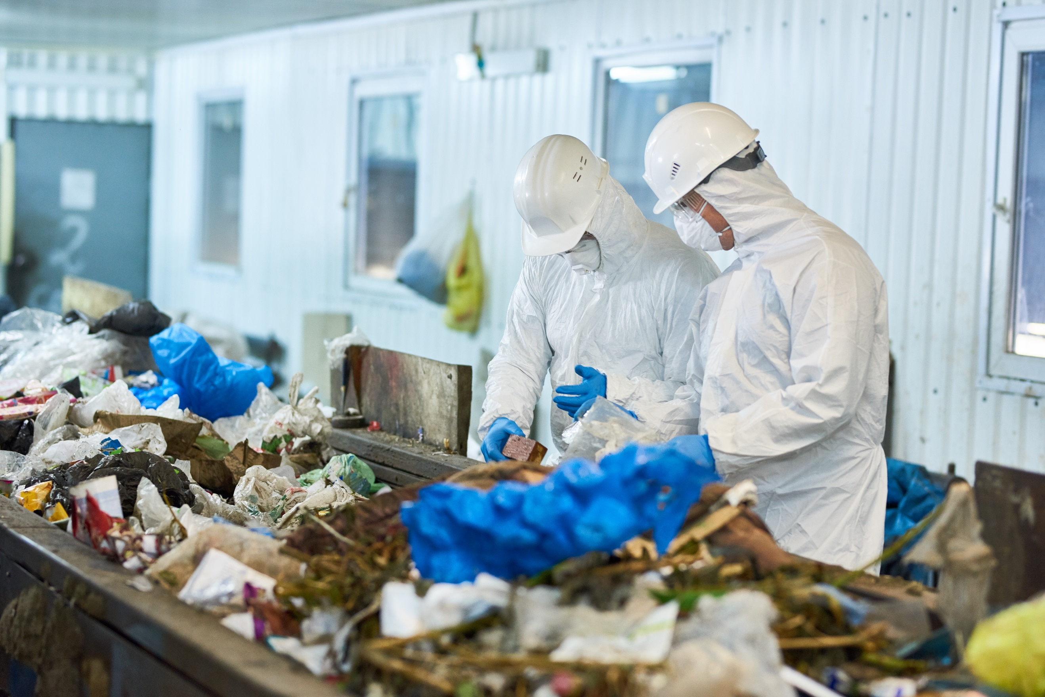
Plastic is collected, transported, sorted, broken down and reformed into new products. Reusing plastic in this way produces less greenhouse gas emissions than making new plastic. Often though, plastics are ‘downcycled’ because recycled plastic does not have the same properties as new plastic. Items such as carpets and clothing can be made from downcycled plastic, but these items often then end up in landfill after one use.

Plus | Minus | Interesting

Environment
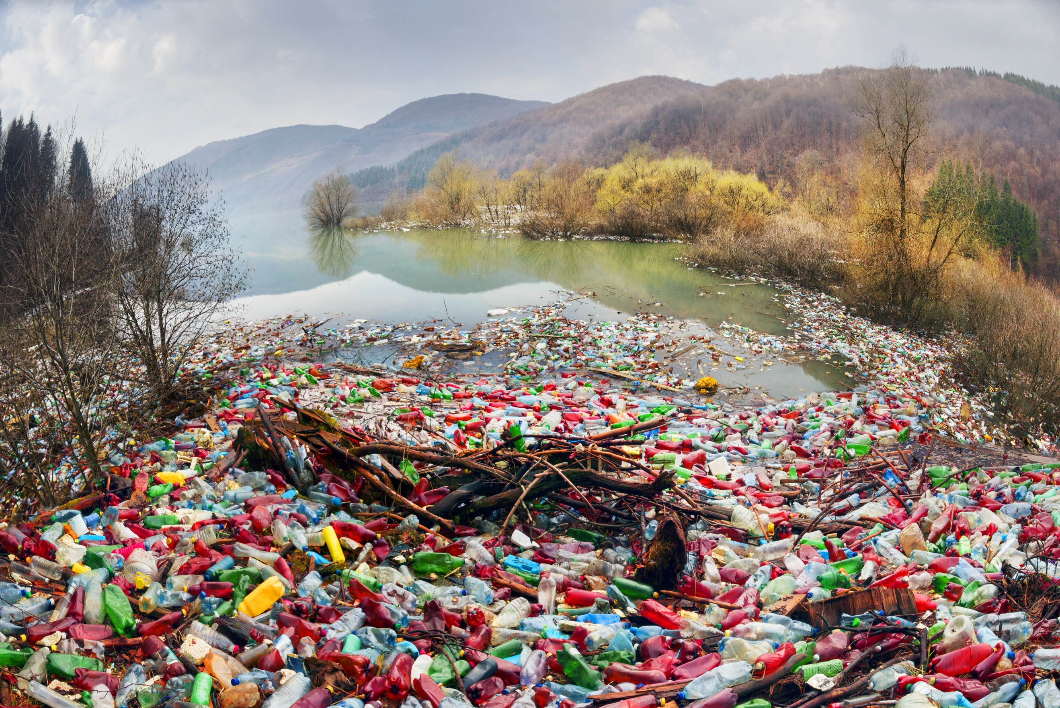
About a third of the world’s single-use plastic waste is not disposed of correctly and it ends up in landscapes, waterways or in our oceans. Research shows that when plastic waste is exposed to sunlight, it can give off greenhouse gases. Rather than biodegrading, plastic breaks down into micro-plastics (tiny pieces of plastic), which pose a serious threat to wildlife.

Plus | Minus | Interesting

Landfill
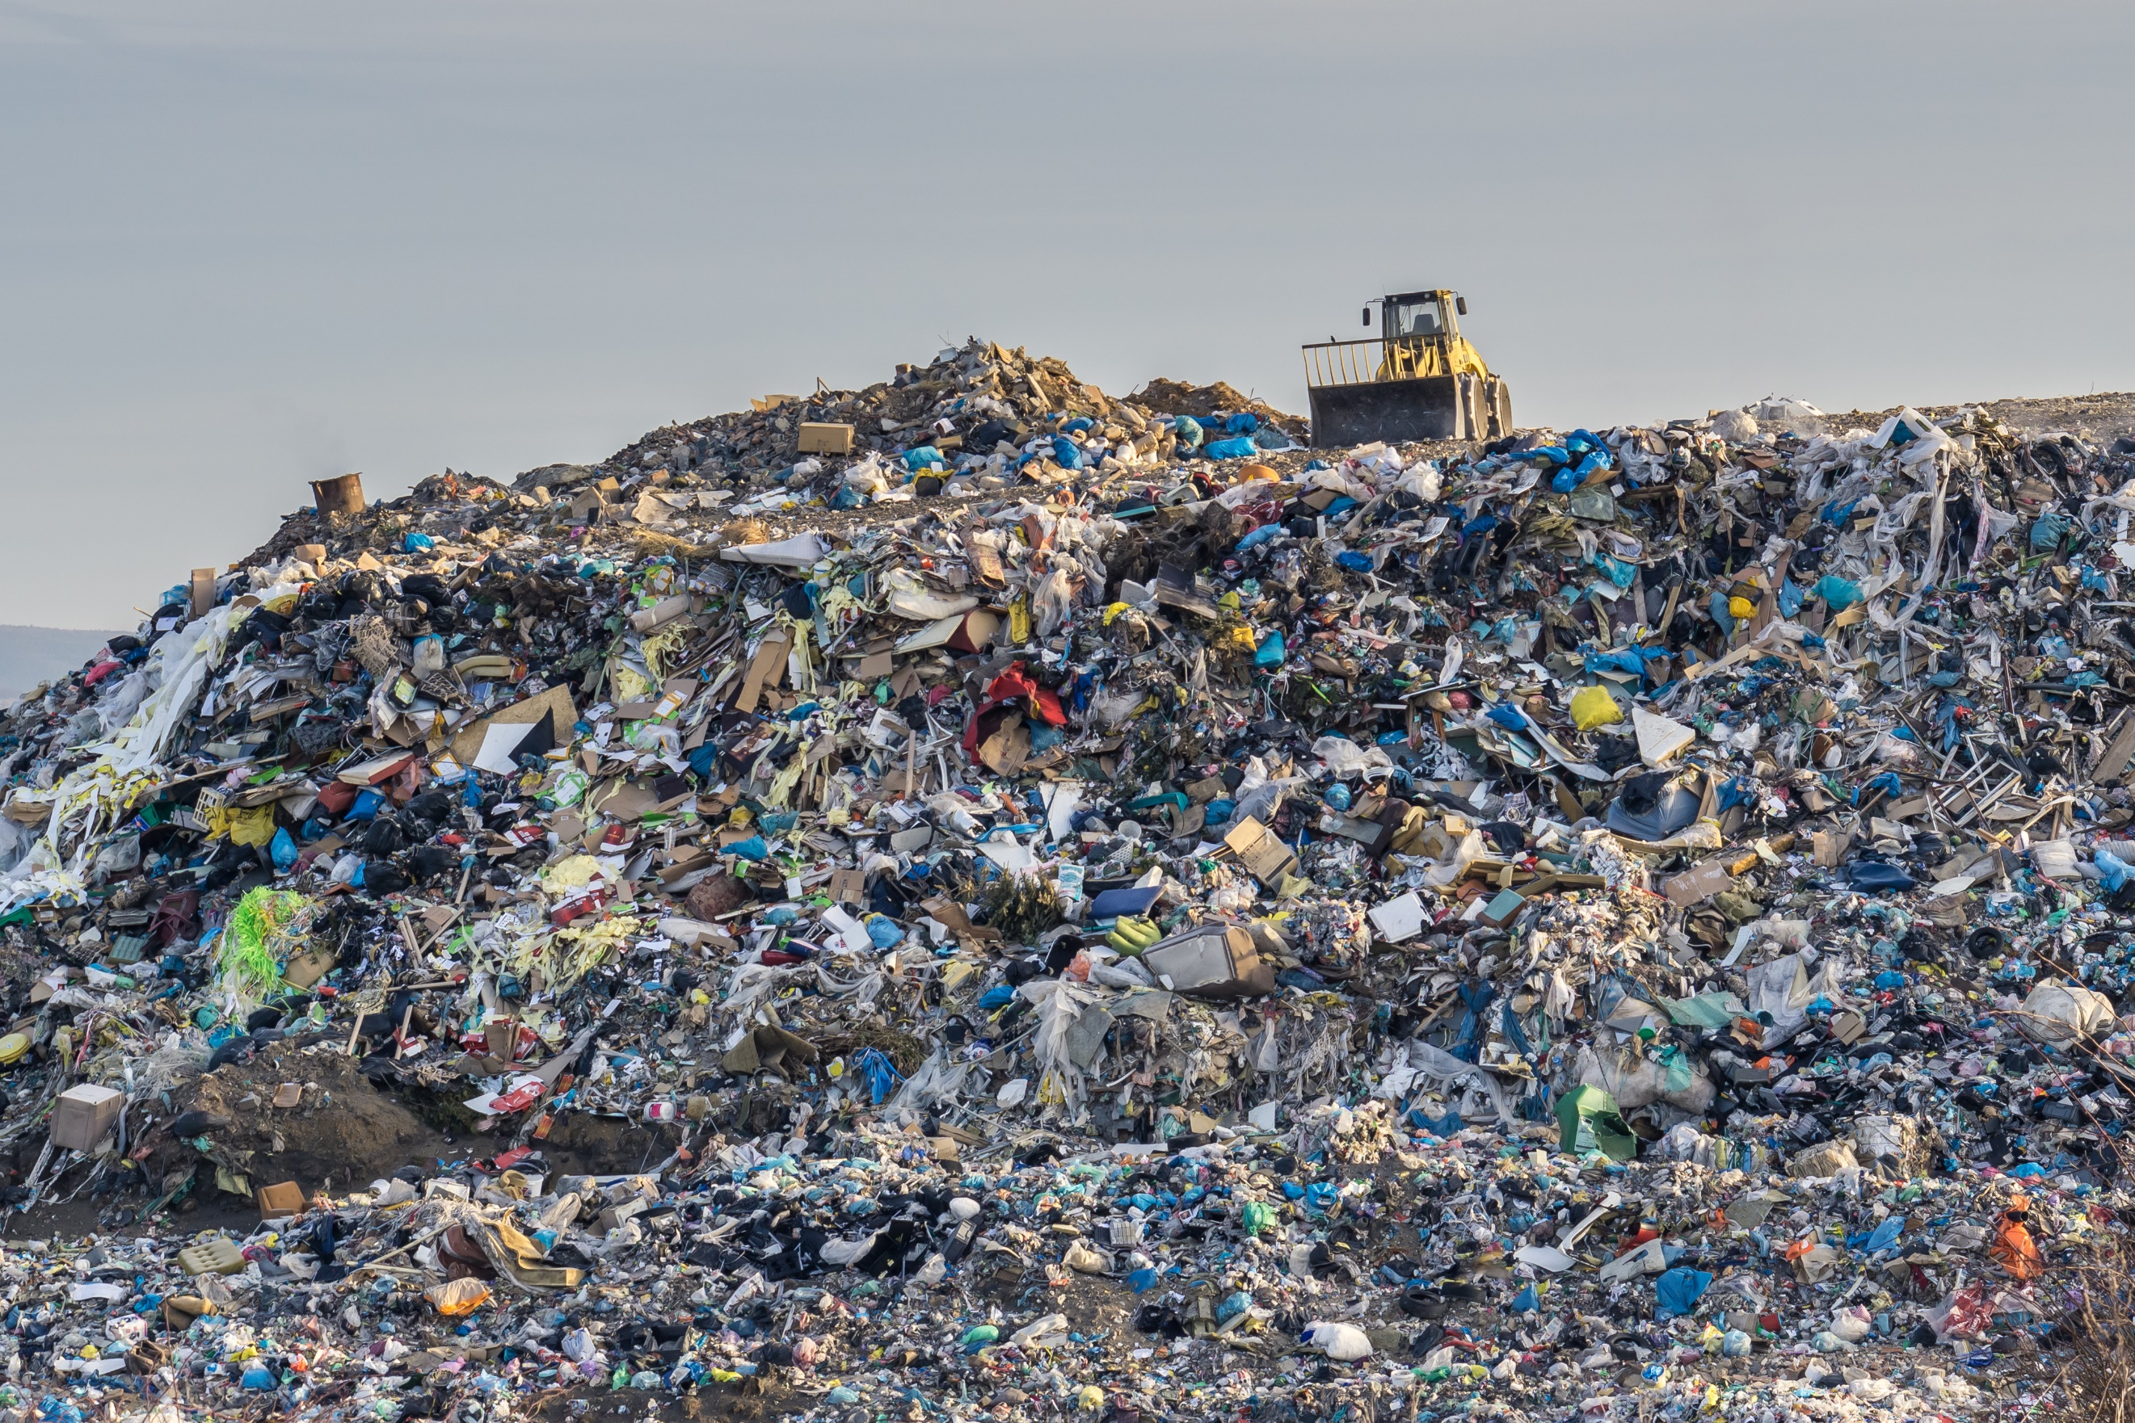

Incineration

Recycling

Environment

