The life of single-use plastic

How is single-use plastic made? Check out this video: https://www.youtube.com/watch?v=aXQ5iJ5lagg

Extraction of crude oil | Oil refining and plastic manufacture | Plastic use and disposal. | Managing plastic waste | Plastic in the environment
Nearly all plastics start as fossil fuels. Oil, a fossil fuel, is extracted from beneath the ground. This oil is not renewable. Once it is used, there isn’t any more.  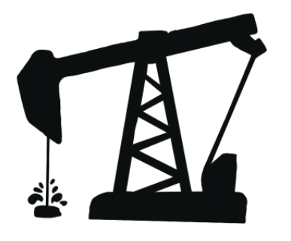 | Oil is refined, which means it is separated into different parts. Different parts of oil are used for different things, e.g. making plastics, fuel for vehicles or lubrication oils to help machines and engines work. | Single-use plastic products (water bottles, straws, disposable coffee cups, carrier bags, food containers) are bought and used but then discarded. | Single-use plastic items are transported to incinerators, landfill sites or recycling centres.  Incineration means plastic products are burned.  In landfill sites, plastic products are buried in the ground. Single-use plastic stays underground and does not biodegrade (break down) for up to 1000 years. | Tonnes of plastic ends up in our landscapes, waterways and oceans. This presents a danger to wildlife and disrupts food chains.  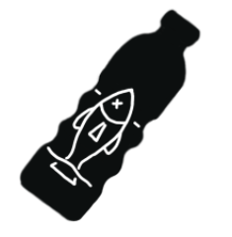
Transport of products and waste at all stages of extraction, production and disposal of single-use plastic cause greenhouse gases (mainly carbon dioxide) to be released in the atmosphere.

The refining of crude oil
