Plastic Life Cycle and Greenhouse Gases

This bar chart shows the emissions produced from the life cycle of single-use plastic in 2019 and predictions about emissions if plastic production continues and grows as currently planned.

Note: A gigatonne is 1,000,000,000 tonnes (roughly 200 million elephants)

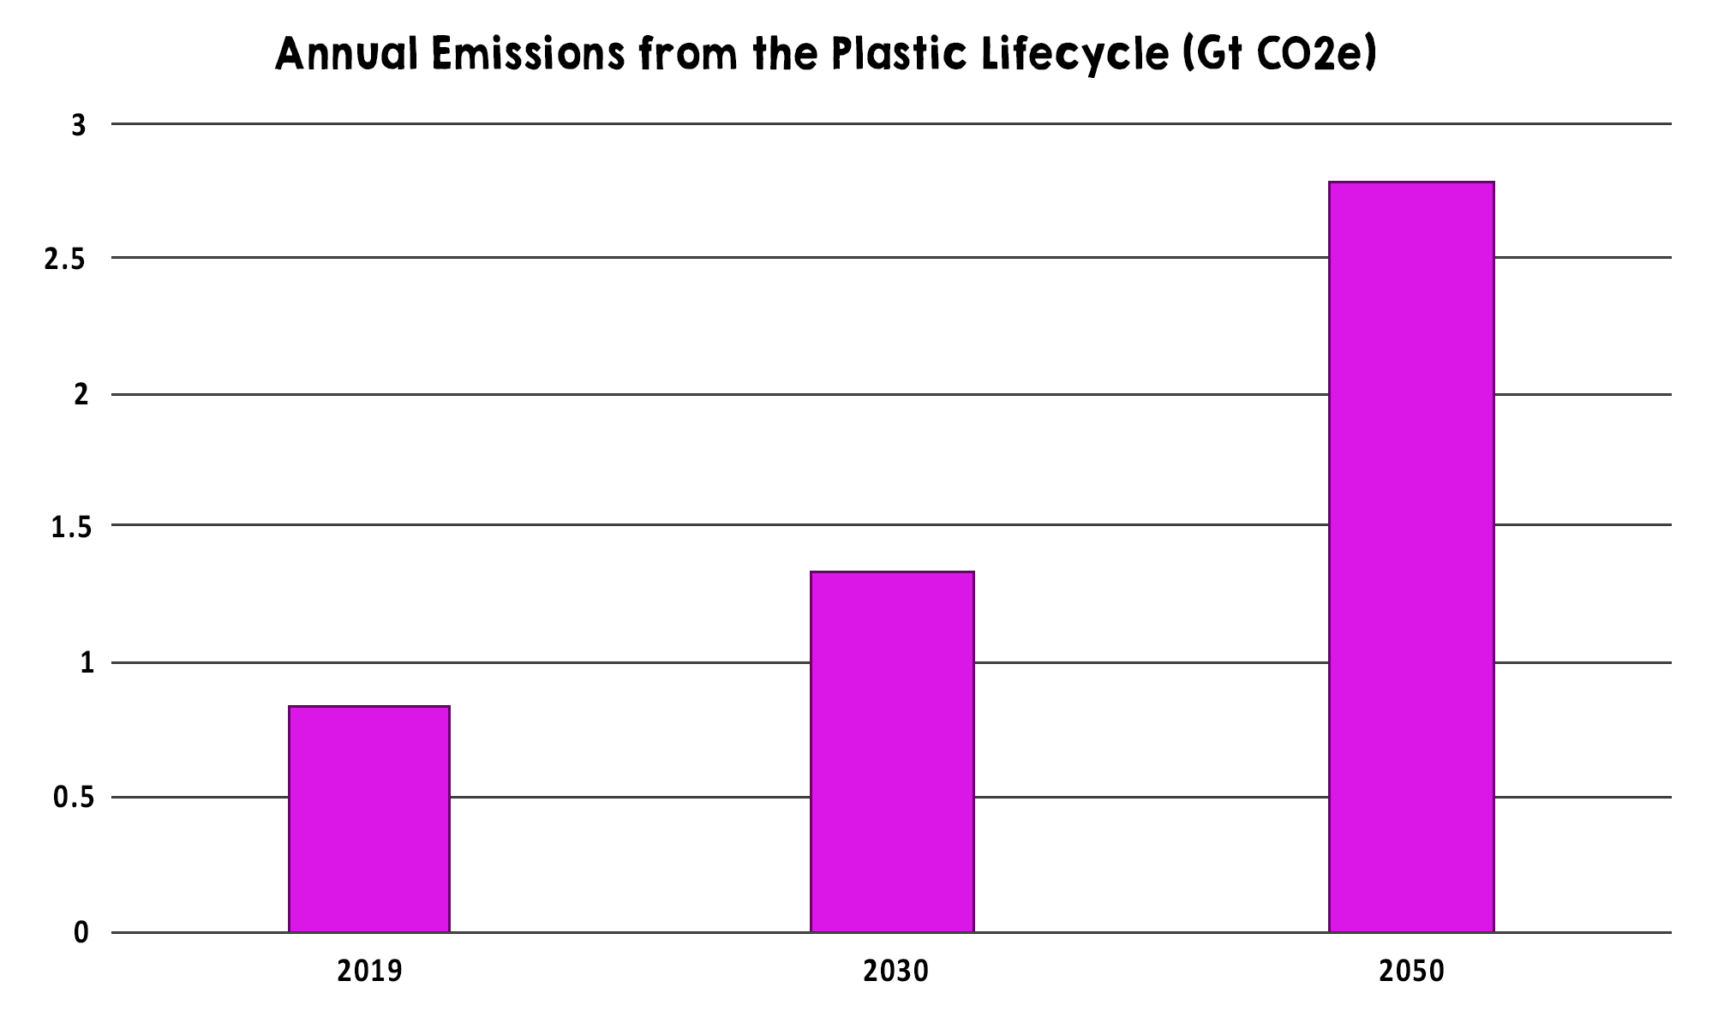
Gt CO₂e
Source: Plastic & Climate: The Hidden Costs of a Plastic Planet (www.ciel.org/plasticandclimate)
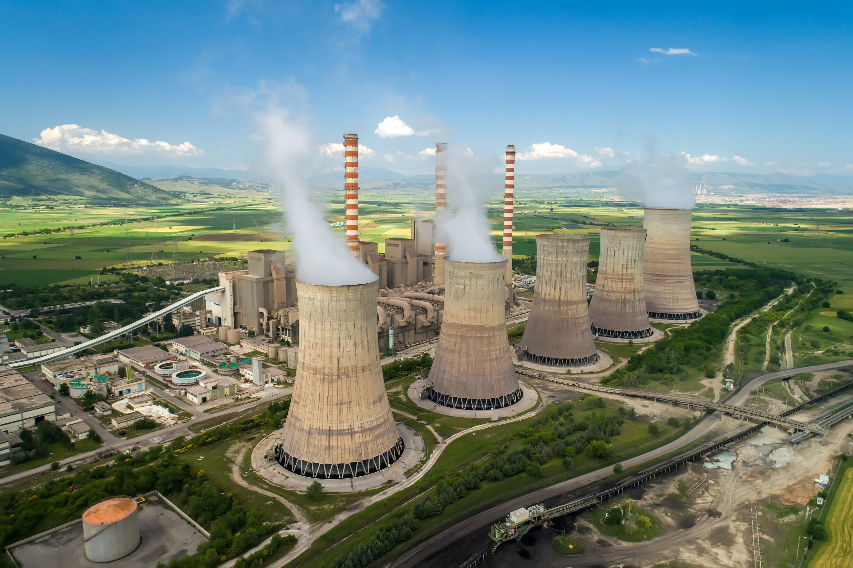
Predicted emissions of 1.34 gigatonnes per year by 2030 are equivalent to the emissions released by more than 295 500-megawatt coal-fired power plants. These plants burn coal and use the heat to produce steam, which powers a turbine. This energy can then be transformed into electricity. Coal-fired power plants release carbon dioxide and water vapour into the air, both of which are greenhouse gases that can affect climate change.

Note: A gigatonne is 1,000,000,000 tonnes (roughly 200 million elephants)

Questions:

- What do you think the emissions from the plastic life cycle look like today?
- What could the emissions from the plastic life cycle be in 2080?
- How could we reduce emissions from the plastic life cycle?
- Why do you think the plastic life cycle creates so much greenhouse gas?
- What do you want to know about plastic production and its effect on the environment?

