Greenhouse Gases

Teacher notes
Greenhouse gases trap heat in the Earth’s atmosphere. They let sunlight pass through the atmosphere, but they prevent this heat from escaping again. They are beneficial in helping to maintain the temperature of Earth but increased emissions of greenhouse gases can increase the temperature on Earth – with damaging effects. Greenhouse gases include water vapour, carbon dioxide, methane and nitrous oxide. Carbon dioxide, produced by the burning of fossil fuels and transport, is the most dangerous greenhouse gas and levels of this gas are at the highest levels ever recorded.

Using the resource:
- Children can use the activity cards to match the descriptions to the names and the images of the sources of the gases.
- Consider alternatives to how these gases are produced, eg renewable energy, natural fertilisers, using public transport or walking/ cycling
- Use this, and other resources (see Climate Change and Plastic Production - The Environmental Impact) to consider how the production and disposal of single-use plastic is contributing the emissions of greenhouse gases. Can children think of ways to reduce these emissions?

Greenhouse Gases

Greenhouse gases trap heat in the Earth’s atmosphere. They let sunlight pass through the atmosphere, but they prevent the heat that the sunlight brings from leaving the atmosphere. They can be beneficial in helping to maintain the temperature of Earth but increased emissions of greenhouse gases can increase the temperature on Earth – with damaging effects. Greenhouse gases include water vapour, carbon dioxide, methane and nitrous oxide.

Water vapour | Carbon dioxide | Nitrous Oxide | Methane
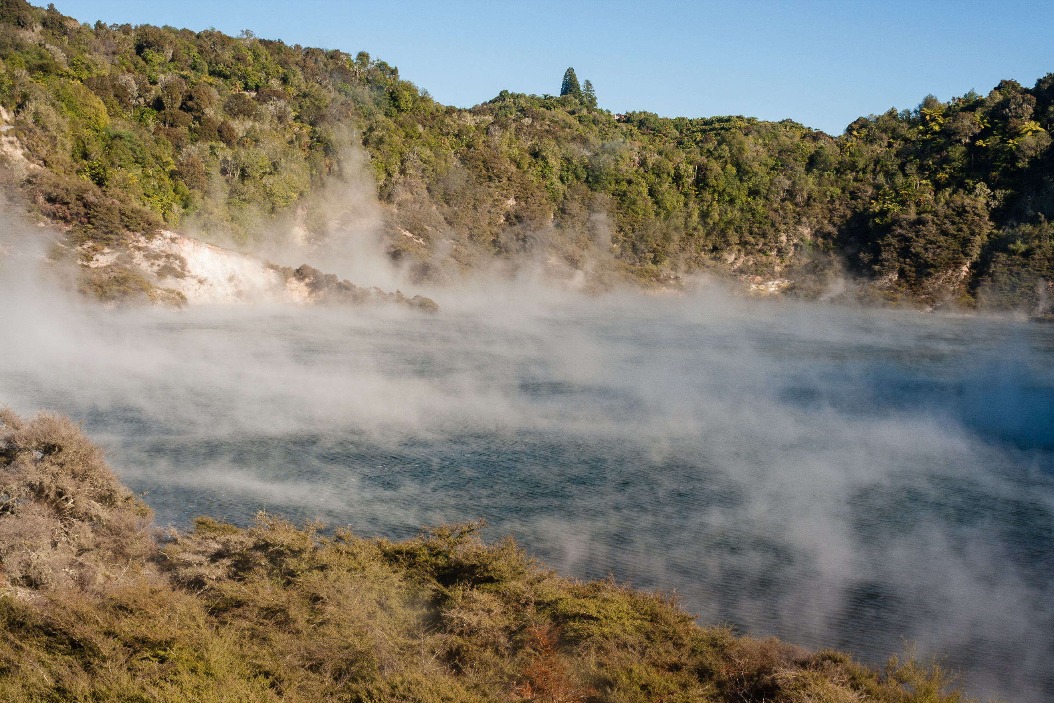 | 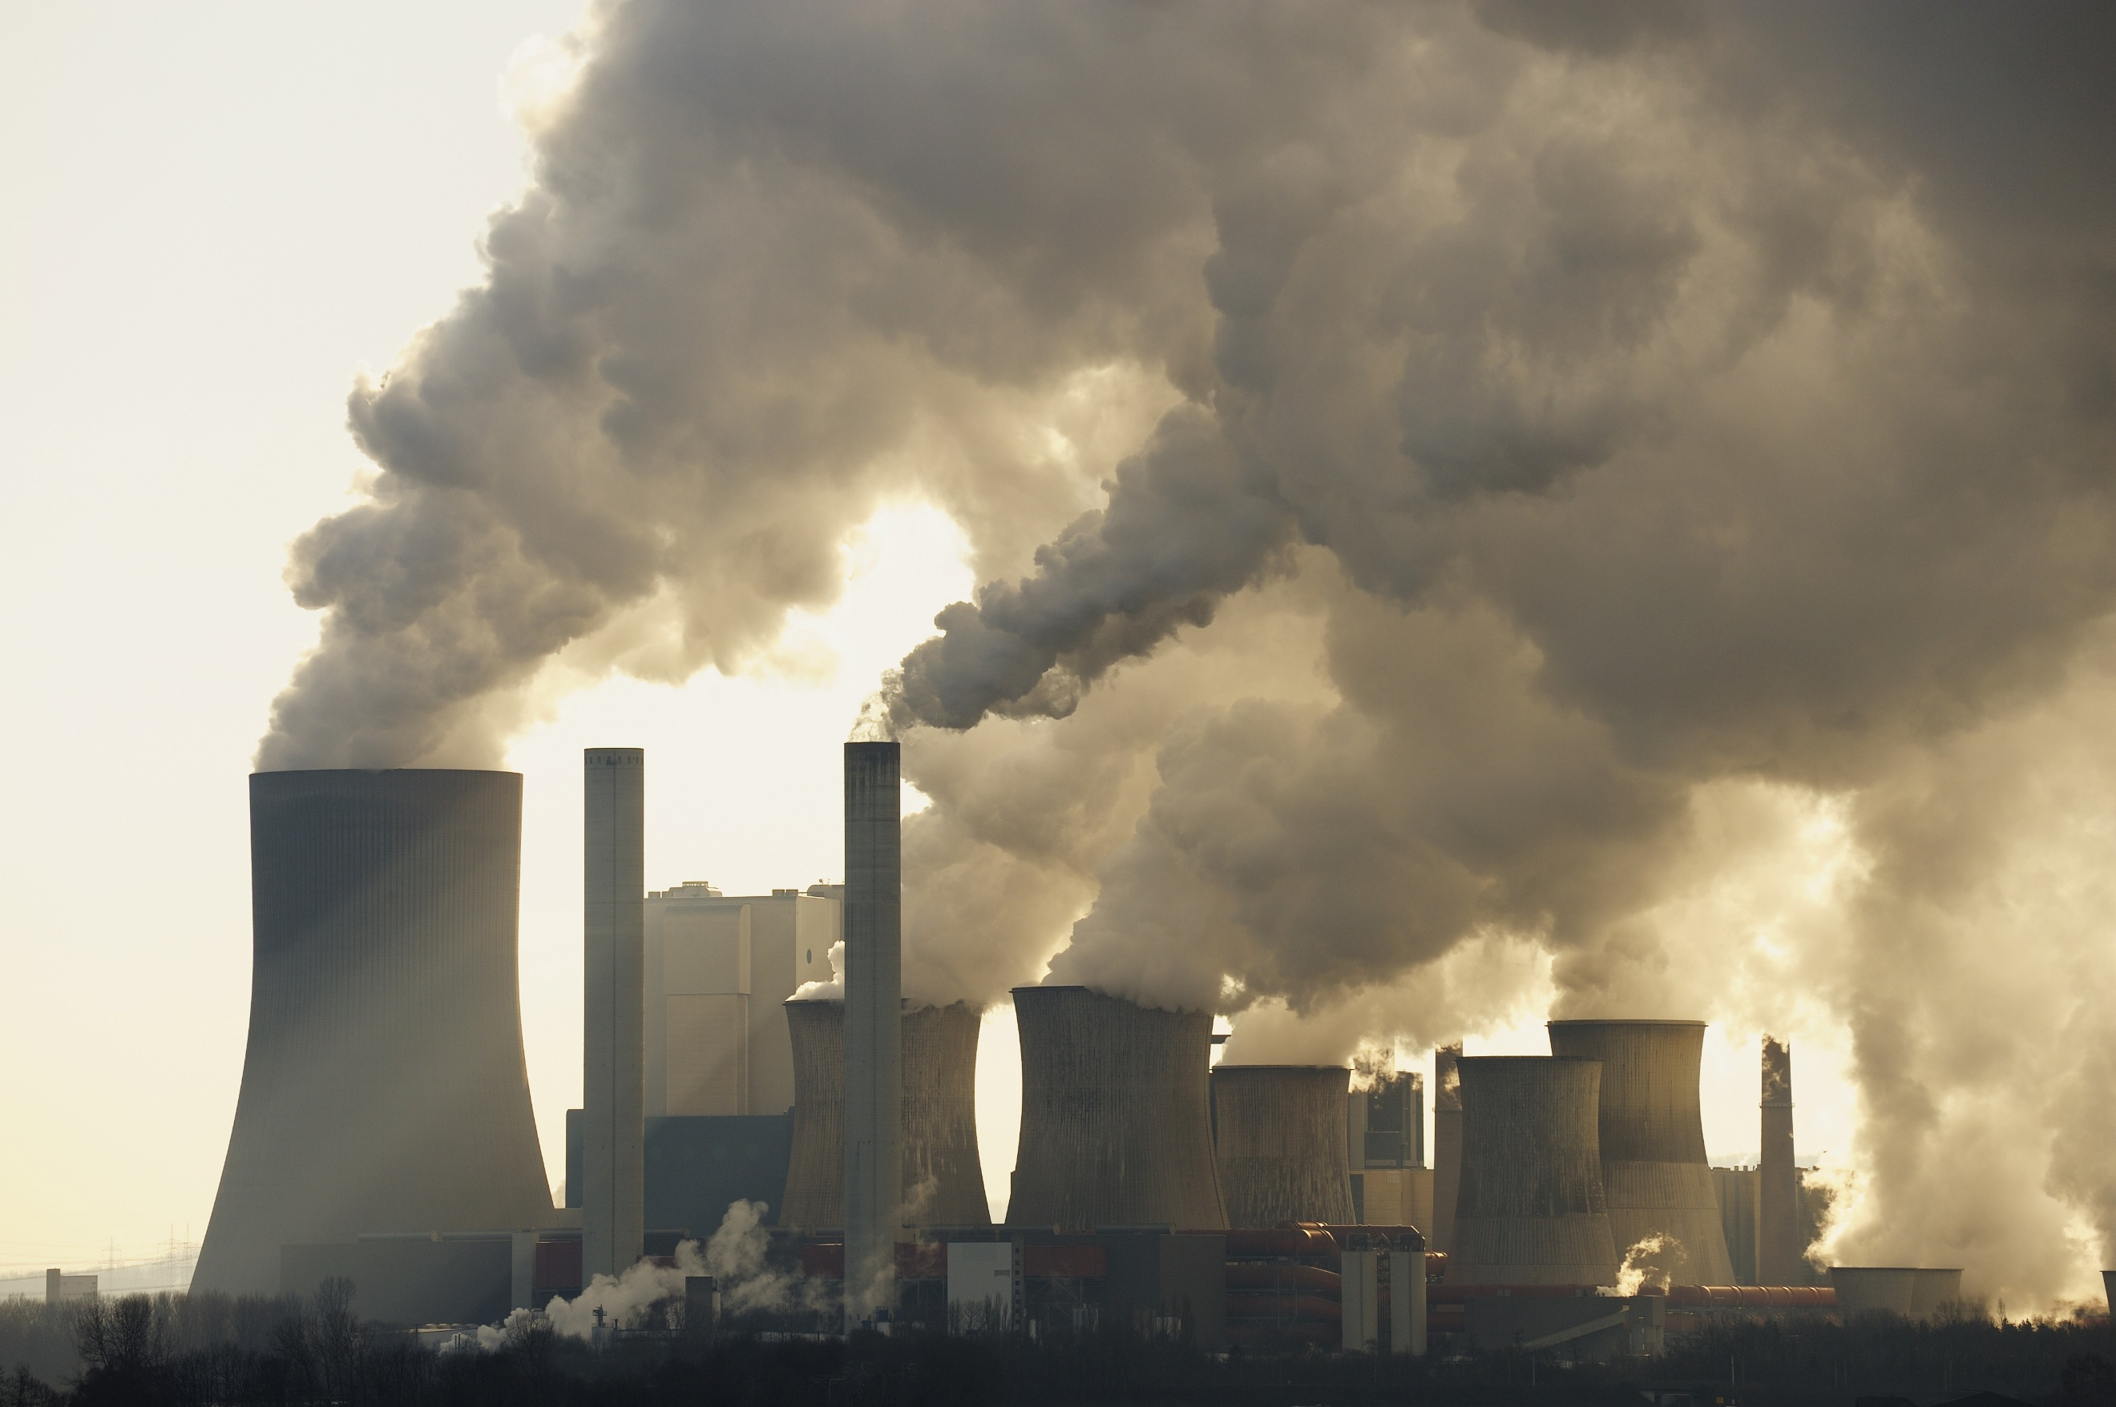 | 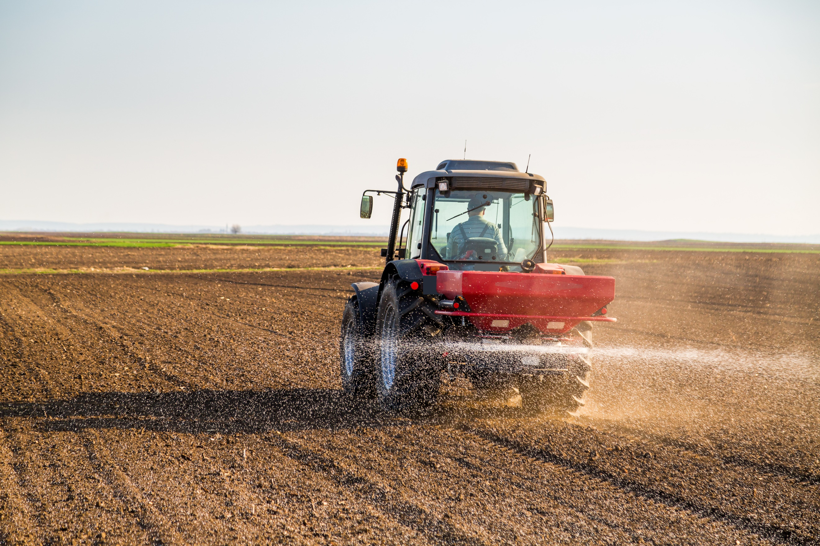 | 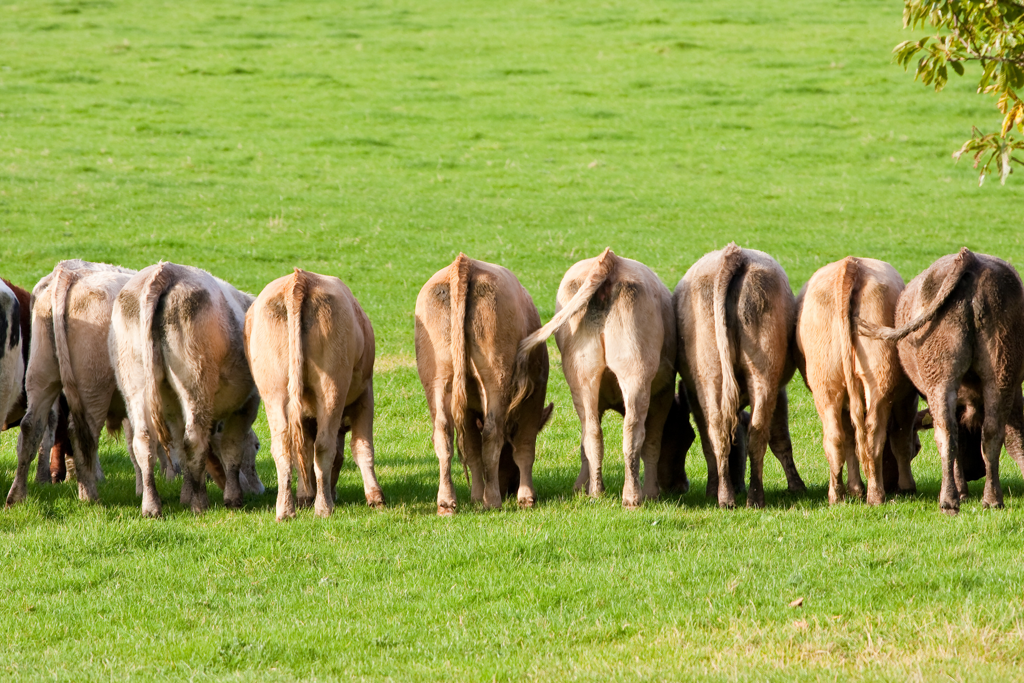
This gas forms when water is heated. It can be found when water boils but it also forms when water evaporates from oceans and lakes. It forms clouds, which block heat from escaping through the atmosphere. Increasing temperatures can mean more water evaporates from the Earth’s surface. | This gas is made from carbon and oxygen. Living organisms expel this gas naturally but it is also released when fossil fuels (oil, coal and natural gas) are burned. This is the most dangerous greenhouse gas, which traps heat in the atmosphere, causing the Earth’s temperature to increase. Levels of this gas are currently at the highest ever recorded. | This is a natural gas and is made from nitrogen and oxygen. It is made by bacteria in the earth and in the oceans. Humans also create this gas from power plants and when fertilisers are produced. This gas can trap heat in the atmosphere but an also damage the ozone layer, which protects us from the sun’s harmful rays. | This gas is made from carbon and hydrogen and it is produced naturally by rice fields, wetland landscapes and cattle (when they expel gas!). It can also be released when natural gas is used and when coal is mined. This gas traps a lot of heat in the Earth’s atmosphere and is thought to be the second largest contributor to global warming.

