Feeding Time
Key Stage 2

NC references
Working Scientifically
- asking relevant questions and using different types of scientific enquiries to answer them
- making systematic and careful observations
- gathering, recording, classifying and presenting data in a variety of ways to help in answering questions
- reporting on findings from enquiries, including oral and written explanations, displays or presentations of results and conclusions
- using straightforward scientific evidence to answer questions or to support their findings.

Animals, including humans
- identify that animals, including humans, need the right types and amount of nutrition, and that they cannot make their own food; they get nutrition from what they eat – consider the impact of plastic pollution on animals’ ability to feed.

Learning objectives
To observe and consider the effects of plastic pollution on animals
To present evidence in a range of ways

Teaching ideas
Explore
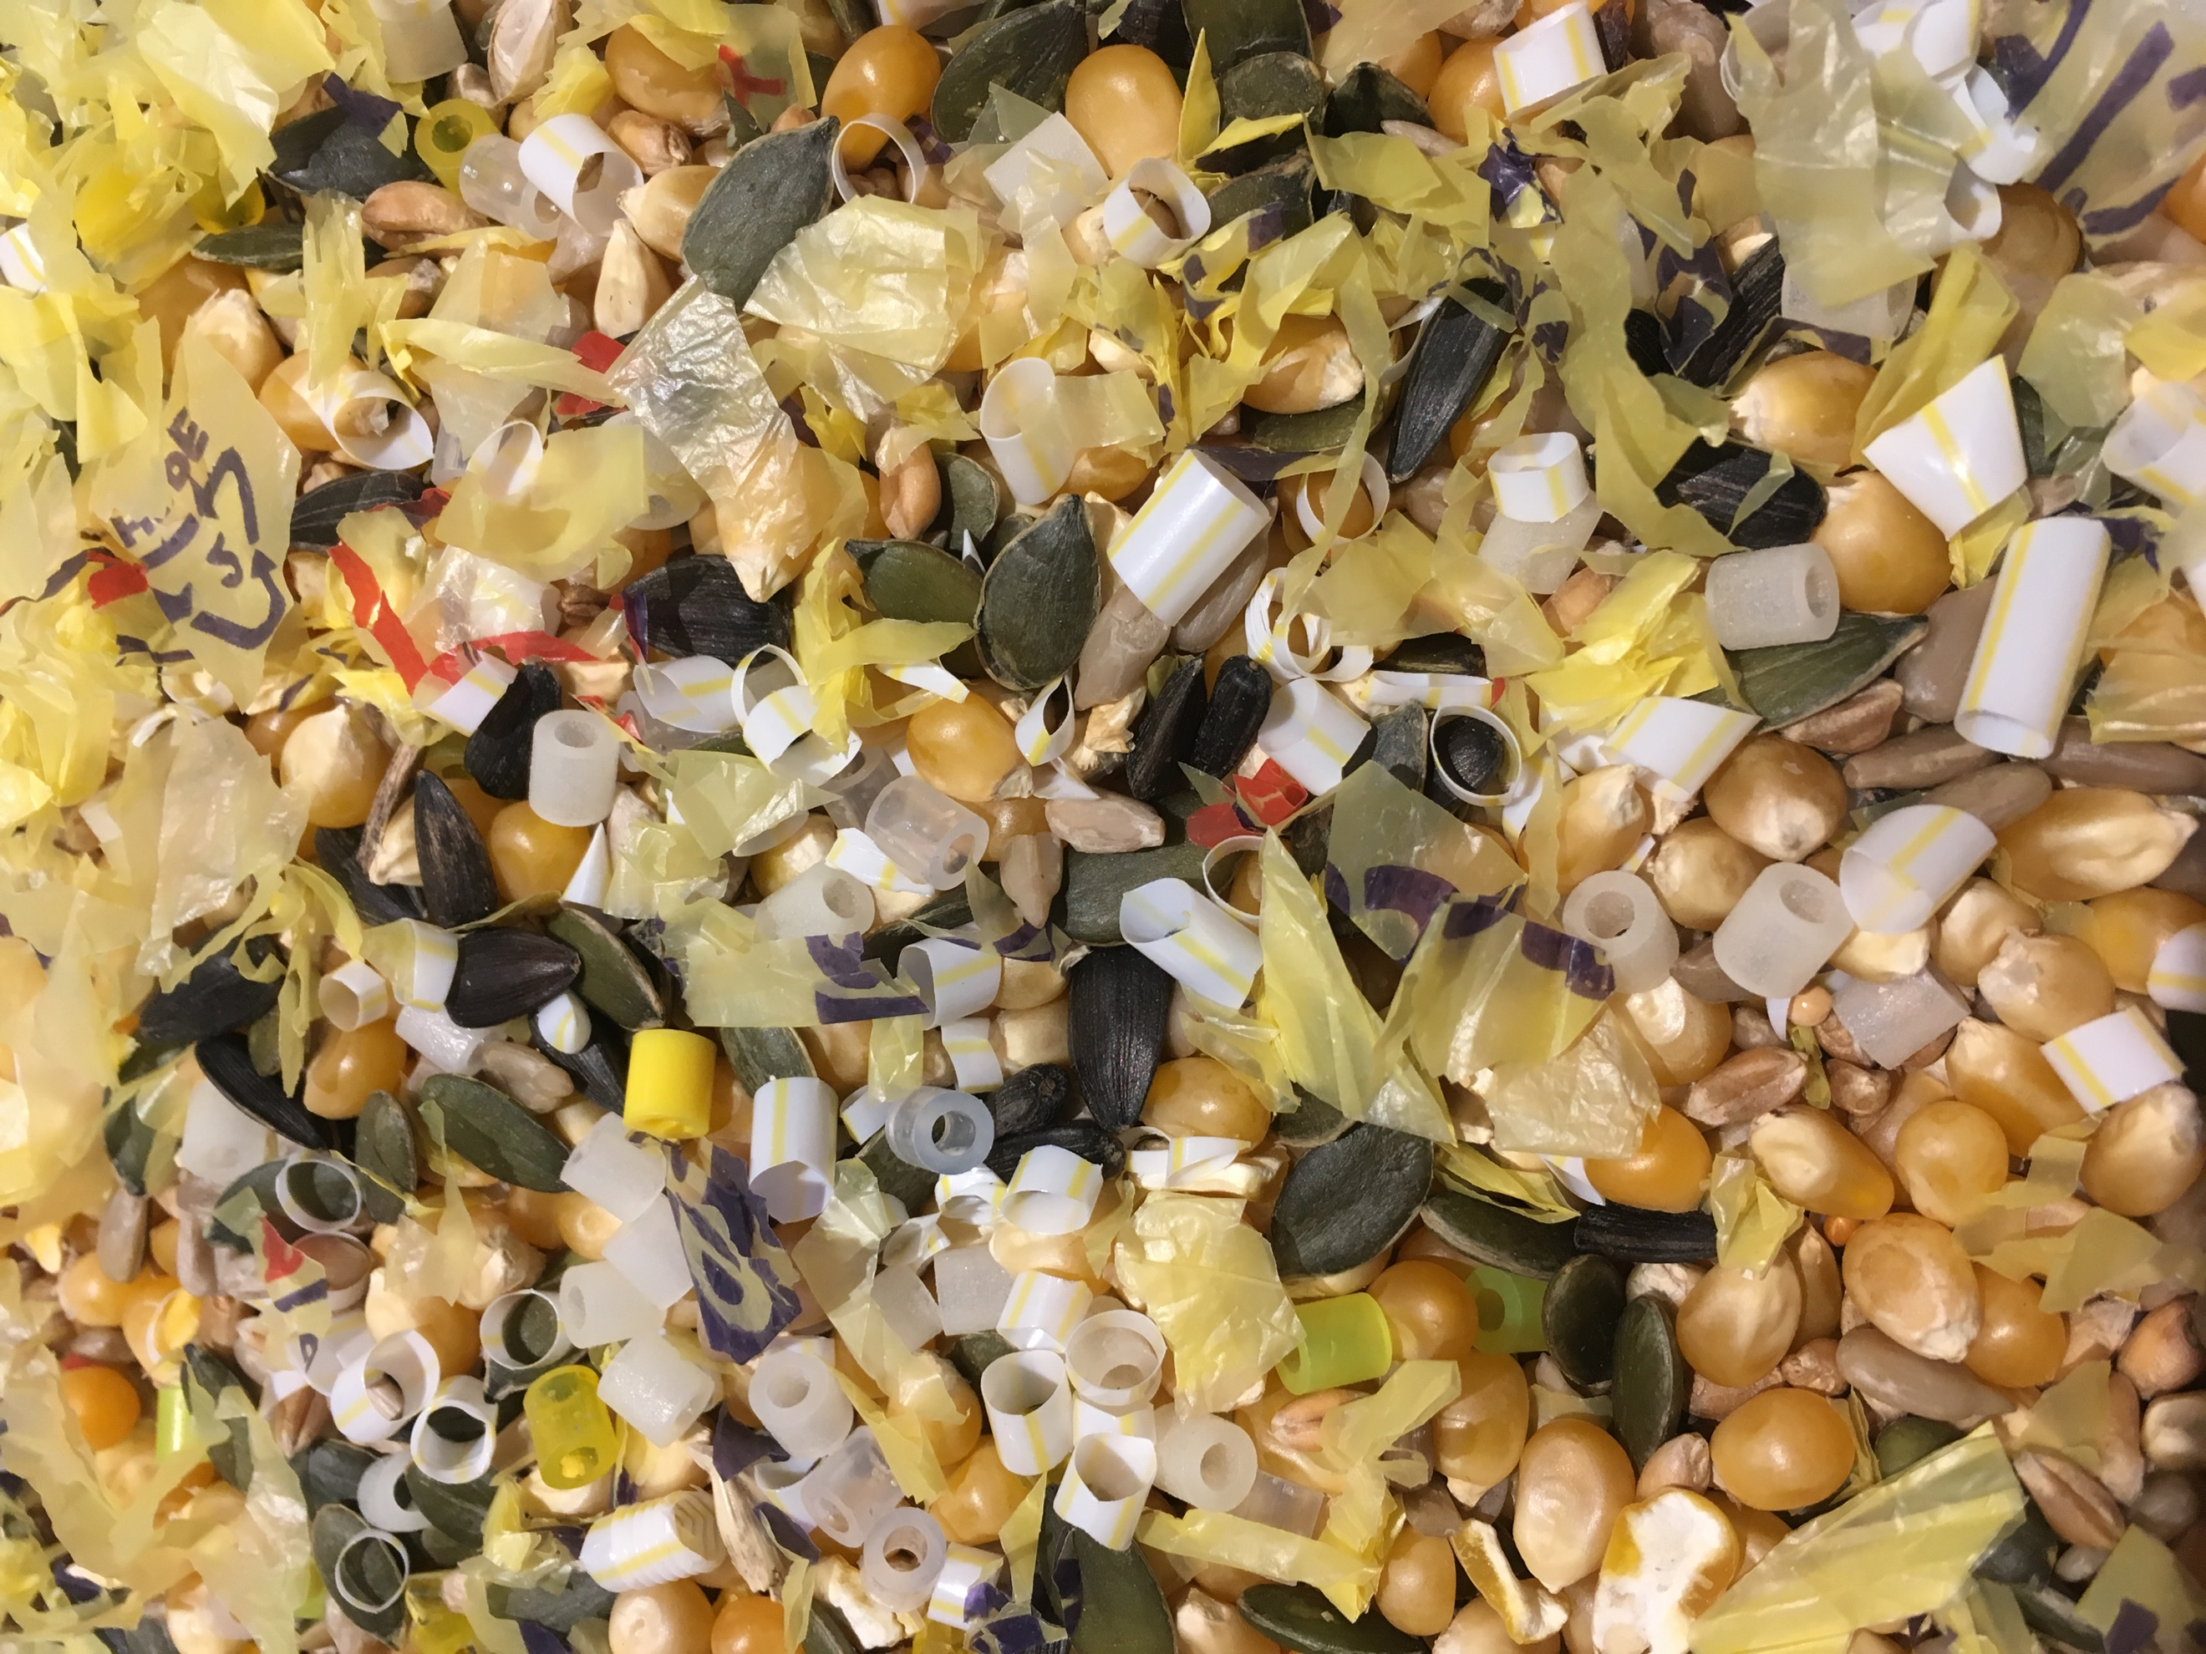
Prepare a feeding mixtures like that shown in the image.
This mixture includes the following items:
- Popcorn maize
- Mixed bird seed
- Tiny plastic beads
- Shredded plastic bags
- Pieces of plastic straws

Ask children to use thumb and forefinger to ‘feed’, grabbing as much food as they can in 20 seconds and placing it onto a plate.

Allow children time to observe and classify the ‘food’ that they collected.
Children can decide on their own criteria for sorting or could use the following categories:
- Food/ not food
- Food/ plastic
- Plastic/ not plastic

Children could weigh or count the items in the sample and then represent the sample as % food and % plastic.

Discuss
What could happen if an animal ate this?

Extend
Model how plastic cannot be digested by animals and can therefore fill their stomachs and deprive them of nutrients from real food: Ask children to remove the food from their sample (imagining that this has been digested) then repeat the feeding activity several times, removing the food and keeping the plastic each time.

What effect could this have on an animal?

Consider
Consider the 4 main plastic polluters – what risk might these cause to wildlife?
Can children find any evidence that single-use plastic items do have an effect on wildlife?
What creatures are most affected by such plastic pollution?

Resources
- Feeding mixture, e.g:
  - Popcorn maize
  - Mixed bird seed
  - Tiny plastic beads
  - Shredded plastic bags
  - Pieces of plastic straws

Next steps
- Using pictures of plastic pollution and its effects on animals as further stimulus, write a letter to persuade people to refuse one (or all!) of the Big 4 plastic polluters.
- Create a poster to raise awareness of the dangers of plastic pollution.
- Go on a litter pick (and log the plastic you collect on the Kids Against Plastic geotagging app) to help reduce plastic litter in your local area.
- Write to persuade a local business or a company related to your school (caterers, cleaners) to reduce the single-use plastic they use in your school.

