UN Goals
Key Stage 2

NC references
English
Spoken Language
- listen and respond appropriately to adults and their peers
- ask relevant questions to extend their understanding and knowledge
- use relevant strategies to build their vocabulary
- articulate and justify answers, arguments and opinions

Learning objectives
To consider the UN’s 17 Goals for Sustainable Development, identifying areas for development within you school.
To consider how your school might become more ‘Plastic Clever’

Teaching ideas
Explore
Explore the headings for the UN’s 17 Goals for Sustainable Development:

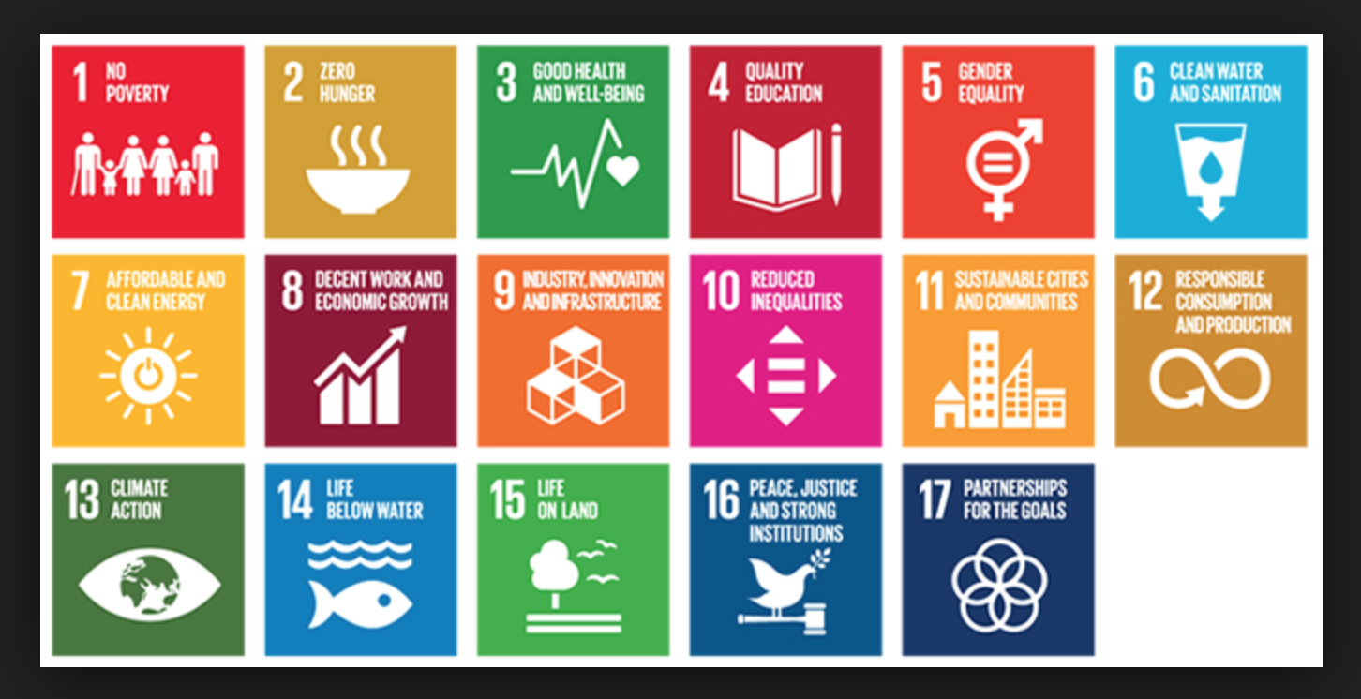

Discuss the headings and what they might mean.
Children might annotate heading with ideas and or/ questions about each heading.
Consider which headings could best to your school setting.

Focus on Goals 12, 14 and 15 and in particular, plastic pollution.
Use the Kids Against Plastic videos:
https://www.youtube.com/watch?v=XWxtlqHjxvo
https://www.youtube.com/watch?v=TLQN2Y4v1bI
and children’s own research to consider how they, the school and the community could become more ‘Plastic Clever’.
Next steps
Ideas for encouraging the school community to be Plastic Clever could include:
- Assessing the school’s use of plastic through litter picks and waste sorting as well as observation and data collection about the use of straws and water bottles etc.
- Presenting to pupils and parents about reducing the use of the Big 4 main plastic polluters.
- Designing and presenting snack ideas that use reusable pots rather than plastic waste.
- Writing or speaking to owners of local cafes and restaurants about becoming more plastic clever.

Resources
Kids Against Plastic website and videos:
http://www.kidsagainstplastic.co.uk
https://www.youtube.com/watch?v=XWxtlqHjxvo
https://www.youtube.com/watch?v=TLQN2Y4v1bI

UN Goals website
https://www.un.org/development/desa/disabilities/envision2030.html

