Plastic Recycling Symbols

Symbol | Meaning
 | This packaging can be recycled by 75% or more of local authorities.
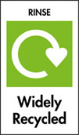 | This packaging must be rinsed before it is recycled so that food waste does not contaminate the recycling process.  Rinsing also helps to keep recycling centres clean and free from rats etc.
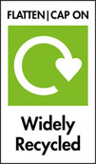 | Crush this packaging so that you have more space in your bin and so that it is easier to transport to the recycling centre.  Keeping the cap on a squashed bottle helps it to stay flat.
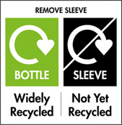 | Check the sleeve that is on this packaging. If it is cardboard, take it off and put it with other cardboard for recycling.  Otherwise, take the sleeve off and put it in the bin before recycling the plastic container.
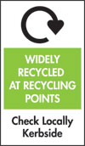 | This is often found on Tetra Pak or drink carton. Check whether your local authority collect and recycle this packaging.

Symbol | Meaning
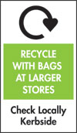 | Some plastic packaging cannot be collected by your local authority but can be taken to recycling collection points such as large supermarkets.
 | Some types of plastic packaging are not collected by local authorities. Check the plastic packaging that is collected by your local authority.
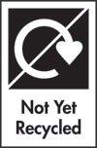 | This packaging is only recycled by less than 20% of local authorities so must be checked. This often applies to crisp packets.
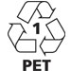 | This is a code to show what type of plastic is used in the packaging. Most local authorities collect plastics with numbers 1 and 2 on as these are used to make most household plastic bottles and packaging.  Plastic carrier bags usually have a number 4 and are currently not widely collected with household recycling.

*Information taken from Recycle Now website
https://www.recyclenow.com/recycling-knowledge/packaging-symbols-explained

Find a video about recycling labels on the video at:
https://www.recyclenow.com/recycling-knowledge/packaging-symbols-explained

