Plastic Hazard
Key Stage 2

NC references
Working Scientifically
- using straightforward scientific evidence to answer questions or to support their findings.
- reporting on findings from enquiries, including oral and written explanations, displays or presentations of results and conclusions
- identifying scientific evidence that has been used to support or refute ideas or arguments

Animals, including humans
- identify that animals, including humans, need the right types and amount of nutrition, and that they cannot make their own food; they get nutrition from what they eat – consider the impact of plastic pollution on animals’ ability to feed.

Learning objectives
To observe and consider the effects of plastic pollution on animals
To present evidence in a range of ways

Teaching ideas
Explore
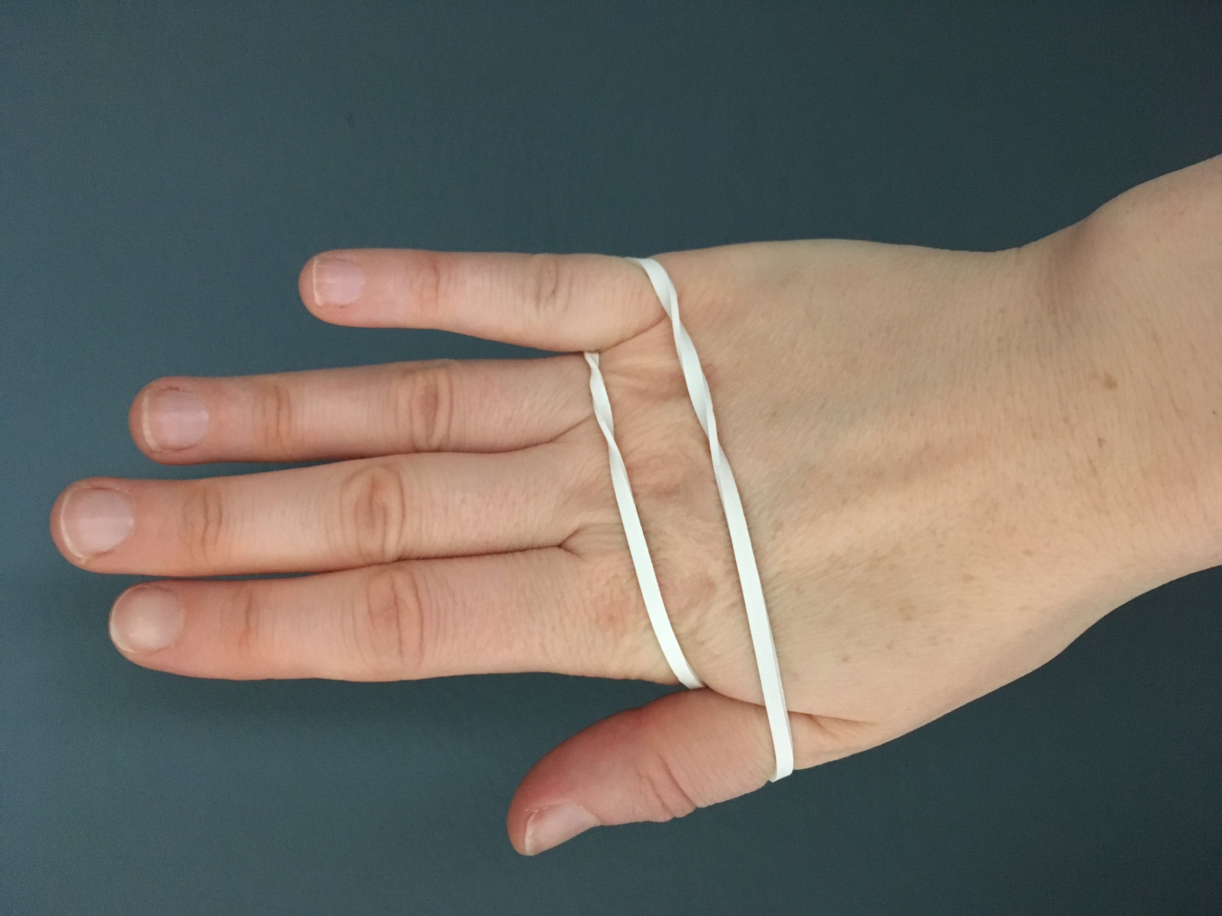
Ask children to put an elastic band across the back of their hand, looped onto their thumb and little finger (as shown in picture).

Without using their other hand (or teeth!), ask the children to try and remove the elastic band- give a time limit of 20 seconds.
- Did they succeed? How did they remove the band?
- Did they need to use anything apart from their hand to help them?

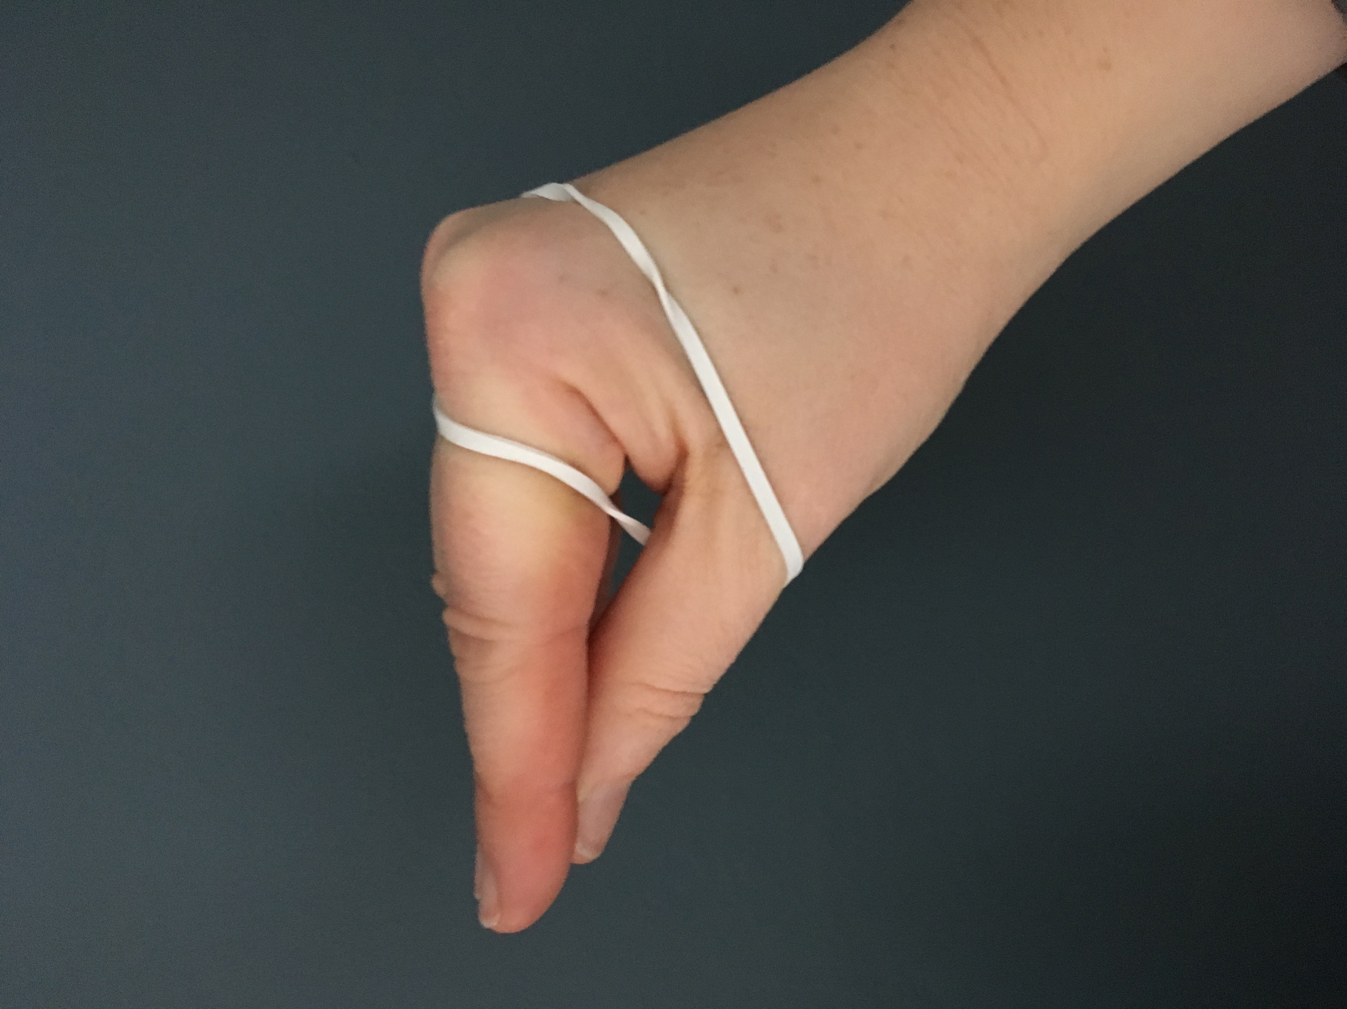
Repeat the investigation but this time, put the hand into a ‘beak’ shape – see picture.

Using the hand as a beak (not separating fingers at all but opening and closing straight fingers and thumb like a beak), now ask children to try and remove the elastic band. Was it easier or more difficult?

Discuss
What kinds of litter/ plastic could act like the elastic band and pose a threat to wildlife?
How might other plastic items pose a threat to wildlife?

Consider
Consider the 4 main plastic polluters – what risk might these cause to wildlife?
Can children find any evidence that these items do have an effect on wildlife?

Resources
- Elastic bands

Next steps
- Using pictures of plastic pollution and its effects on animals as further stimulus, write a letter to persuade people to refuse one (or all!) of the Big 4 plastic polluters.
- Create a poster to raise awareness of the dangers of plastic pollution.
- Go on a litter pick (and log the plastic you collect on the Kids Against Plastic geotagging app) to help reduce plastic litter in your local area.
- Write to persuade a local business or a company related to your school (caterers, cleaners) to reduce the plastic they use in your school.

